Unit 6 Assessment 2

Due- 25th November

Name – Emre Adcock

# Introduction:

I have recently joined a web development company that is called Hot Beans Web as a junior web developer. I have been asked as part of my induction and training to create a new section for the company’s website which promotes the company to prospective employees as they need to recruit more web developers. The company has asked me to create and evaluate comprehensive designs for the website which include identification of user requirements, visual designs for each of the pages, alternative design options and technical documentation. For each page I have been asked to include the following things, a profile of the company itself, profiles of existing trainee web developers, job specifications and required qualifications, an on-line application form and links to the web development course.

# Purpose Of Project:

The purpose of this project is to create a website for the company “Hot Beans” which allows for users to come across this website and help them find potential courses to apply for and its even good for skilled people who are seeking employment as there is a page on the website called “Jobs”. The website also allows for people who may be interested in web development to look at the “About us” page on the website and read information about what the company is about and potentially apply through the “Application form”

# Target Audience:

The target audience for this site is people who have completed training courses or qualifications related to web development and are now looking for a job as a web developer.

# Client Requirements:

The client requirements are for me as the junior web developer to create a new section for company's website which promotes the company to prospective employees. This is done through the company asking me to do the following: Create a profile of the company itself, create profiles of existing trainee web developers, job specifications and required qualifications, an on-line application form and links to the web development courses

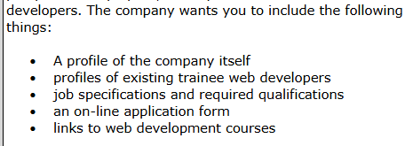

# Constraints:

Some constraints of building the website are the time frame that I must do it. This is a constraint as it means that I cannot go to the full extent of making the website to the best that it can be although within the time frame it will easily be manageable to create a great website which does meet client requirements and target audience.

# Benefits:

Some benefits of building this website are that it gives me more experience the more websites I build meaning in the future I will be able to build and better more websites. Another benefit of this website is that it allows people who may also be junior web developers to discover jobs whilst using the website or even people who come across the different courses which will be displayed on the website and means that people can gain heavy skills from the website.

# Success Criteria:

Functional Criteria:

* The website must meet the client requirements which means that the website must contain all the things that have been asked of me.
* The website must meet the target audience which means that it is designed for people who have completed training courses or qualifications related to web development and are now looking for a job as a web developer.
* The website must be navigational meaning that the navigation bar must work and all the links that may be on some pages redirect you to the right things.

Non-functional Criteria:

* The website must have matching colour schemes for each page.
* The colour scheme must be easy to read to make it more accessible for people who may have visual impairments.

# Planning:

Time Plan:

Next, I have created a time plan so that I can see how I am going to use my time effectively to make the website and make sure that it meets client requirements and reaches to the target audience.

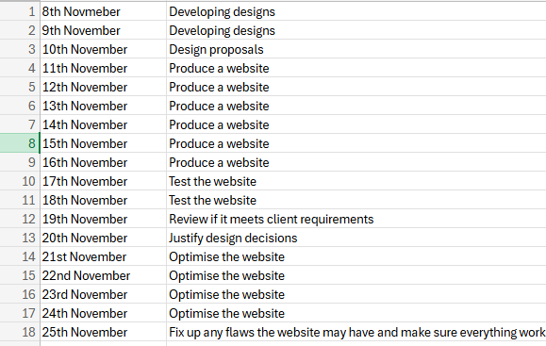

# Diagrammatic representation of proposal and justification of my decisions:

Design 1:

This will meet the target audience as it is visible to see that there are pictures of people who are working on computers in office environments which fits for people who have completed training courses or qualifications related to web development. Since this is only the design, I have decided to use the website lorum ipsum to get random text although in the real website it will contain truthful information that will fit client requirements. This is a desktop design. I chose the design as it is clean and simplistic and allows for the user to easily view the pictures and text. Is very accessible although the text potentially could expand further down the screen to allow more information onto one page. The design also allows for users to see the image that is related to what the text is saying on the left allowing them to get a sense of what they may be doing once working that job or the environment that they may be working in.

Design 2:

Again, this will meet the target audience as it is visible to see that there are pictures of people who are working on computers in office environments which fits for people who have completed training courses or qualifications related to web development. Since this is only the design, I have decided to use the website lorum ipsum to get random text although in the real website it will contain truthful information that will fit client requirements. This is a desktop design. I chose this design as it allows for simplicity and looks very clean and visible to users, there are no abstracting colours which make the text hard to read making it easily accessible. Although it is like the other design these colours may make the website look more appealing to users and doesn't feel as depressing meaning that more people may feel as if they want to use the website more. I placed the navigation bar in the top left corner to make sure that it is easily visible to users and don’t have to struggle looking around the screen trying to find it.

Mobile design 1:

Again, this will meet the target audience as it is visible to see that there are pictures of people who are working on computers in office environments which fits for people who have completed training courses or qualifications related to web development. Since this is only the design, I have decided to use the website lorum ipsum to get random text although in the real website it will contain truthful information that will fit client requirements. This is a mobile design. This design is very user friendly as the navigation bar is easily visible for use and the text is big and easy to read, I have done this so that users that may be on older or smaller versions of mobile phones they are still able to easily see the text and the picture.

Mobile design 2:

Again, this will meet the target audience as it is visible to see that there are pictures of people who are working on computers in office environments which fits for people who have completed training courses or qualifications related to web development. Since this is only the design, I have decided to use the website lorum ipsum to get random text although in the real website it will contain truthful information that will fit client requirements. This is a mobile design. I have added a different variety of colours compared to the first design which allows for more contrast and more visually appealing. I have decided to space things out more in this design as in the previous design it was very compact which may have made the website very confusing and hard to use for some users.

Application:

This my design for my application form which will be a page on the website which will contain the user to enter their credentials and submit their information which will be collected and will be sent back to the page” About us”. This is a desktop design. I have added a lot of white space for the application form so that users don’t feel as if we are pressuring them to apply and allows them to strictly focus on the application form as it may be hard for users if they are being bombarded with loads of information.

Mobile Application:

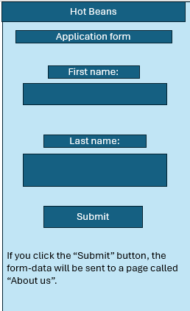

This my design for my application form which will be a page on the website which will contain the user to enter their credentials and submit their information which will be collected and will be sent back to the page” About us”. This is the mobile version of the application design. I could not leave as much white space for this design as it is a mobile design, and the resolution is too small although it still gives the user plenty of space to see everything and if they ever want to go back after applying, they can always just click submit and a clear statement at the bottom which states that they will be taken back to the main page.

Application design 2:

For this design it is again another desktop version and has large white space to again allow for users to solely focus on applying. Although for this design I have decided to add an email address and phone number so that the people who own the website will potentially be able to send them notifications if they subscribe and will get updated with the latest information about the website or any potential changes that may be made.

# Review of Proposal:

I am now going to get feedback from two different people on each of my designs for the website and they are going to give me feedback on how I could improve/change some aspects of it to make it better.

Person 1:

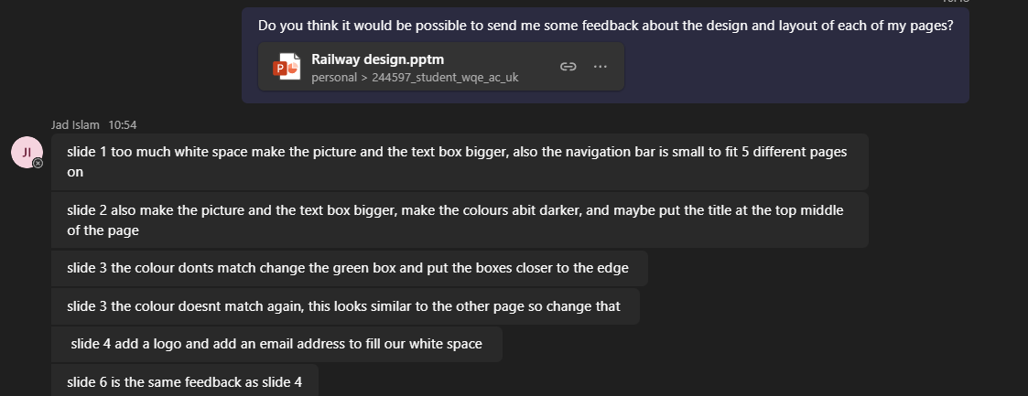*When the person reviewing my work says slide 3 twice, he meant to go up in order so the second slide 3 is slide 4 and the next is 5 and so on*

Design 1:

He says that there is too much white space which I do agree with him there is a lot of white space although I have purposely done this so that the user of the website doesn’t feel overwhelmed with information whilst browsing due to the fact that my website will contain high amounts of information it would be best to not put it all over the screen and leave some white space so I will not be making a change to this in my website. He also advised me to make the picture and text box bigger which I think is an amazing idea as some visually impaired people may be unable to see this if the text is too small to read so I will be making a change to this in my work. I do also agree with the navigation bar being too small which will be changed on the website so that all five pages will be able to fit.

Design 2:

My design 2 is partially like my “About us” page so I can understand why he suggested the same things such as making the text box and pictures bigger which I will implement into my website so that visually impaired people also have a way to access the website without struggle. He stated to make the colours darker which I will not be implementing as I feel as if having brighter colours has a better effect on the website as people will find it more visually appealing and will want to continue using thew website. He also suggested that I move the title to the top middle of the page which would be a bad idea since the navigation bar will most likely need to be extended to fit all five of the pages so I will not be implementing this suggestion.

Mobile design 1:

He said that the colours don't match which is very true and I will be changing this design so that they do match. He also said to widen my boxes within the design so that they fit to the edges which is a good idea as it means that more information will be fitted into the boxes so I will be implementing this change as it means that users will be able to view more text in one page.

Mobile design 2:

Again, he said that the colours don’t match which is again true and will be changed so that they match. He again says to widen the boxes as the design is very similar to slide 3 to allow for more information to be on one page at a time making like easier for the user as they won’t have to navigate as much for information. Aga

Application:

He suggested that I should add a logo and an email address to fill out the white space which I will not be implementing as I have used this amount of white space purposefully so that the user can solely focus on the application form without being bombarded with loads of text.

Mobile application:

For the mobile application he stated that he would give the same feedback as he did for the desktop application which again I will not be implementing as there barely any white space and all the components are quite close together, adding a logo and email address are nearly impossible due to it not being suitable for the resolution which is why I have not implemented this.

Application design 2:

The only feedback he gave was for me to change the green background as it may not be suitable for people who may have eye conditions or sensitive eyes which is true, and I will make this change to a lighter easier colour on the eyes so that it is more accessible for people.

Person 2:

Design 1 and Design 2:

He said for my design 1 I could make the navigation bar bigger which is a very good idea, and I will be implementing this into my work as it will make the website more usable as some people who may have visual impairments may not be able to see the navigation bar. And on a website like this where it is very information based it is necessary that users can easily find where the navigation bar is

Mobile Design 1 and Mobile Design 2:

He said for these designs I could make the images a bit bigger as the mobile screen is small and may be hard to see and I do agree so for the mobile design I will change the images to be a bit bigger so that users who may be viewing on small mobiles will be able to view it which will make the website have more usability as more people will be able to access it and it is not just limited to desktop.

Application design 1 and Mobile application design 1:

He said that I could add more things in the form than just the first and last name which I have done as in the application design 2 which is my updated design I have added an email address, phone number etc. This means that we will be able to gather more information on our users and will be able to also fill out some more white space.

# Build the Website:

I set up 5 pages and used html code on visual studio code and then started on the first page.



For the head I have put a link to the style sheet w3 schools which I have used to support me with a lot of the code I have been writing. For the head I have added a banner across the page which I have made a dark grey with the title “Hot Beans”.

I have then decided to add something which would allow me to put a picture with text alongside of it. So that when I was creating the website for the company “Hot Beans” I could have a picture that would represent the information beside it.

This would give me 2 split containers where on one side I could put a picture and the other side the information.

My client then asked me to create 5 pages so I had to add a navigation bar

# Testing the website:

Test 1:

We are going to be testing if the navigation bar is working. The way in which we are going to do this is as we are already on the “About us” page I will click onto the job page which should change all the content related toward the jobs.

(Before)

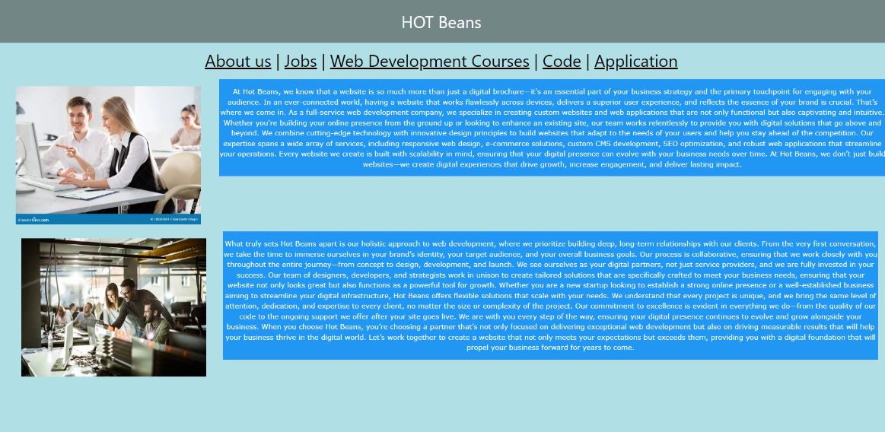

(After)

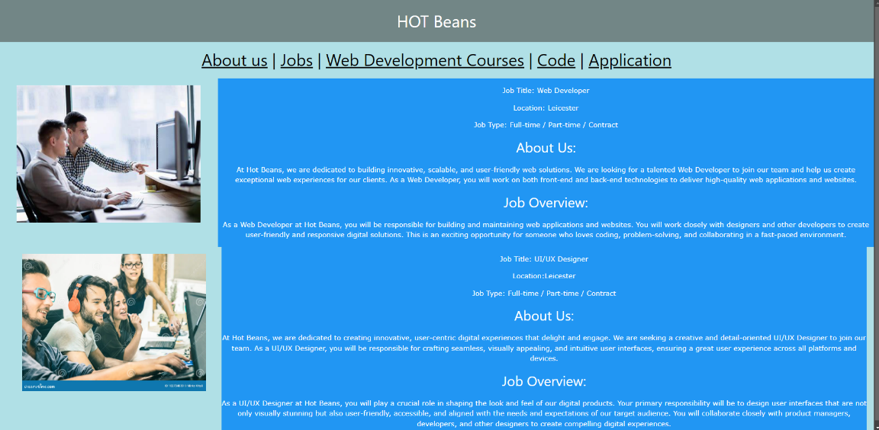

As you can see the test was a success meaning that the navigation bar works fine.

Test 2:

For test 2 we are going to be testing to see if the links on the “Web development courses” page work and make sure that it redirects them to the right website.

(Before)

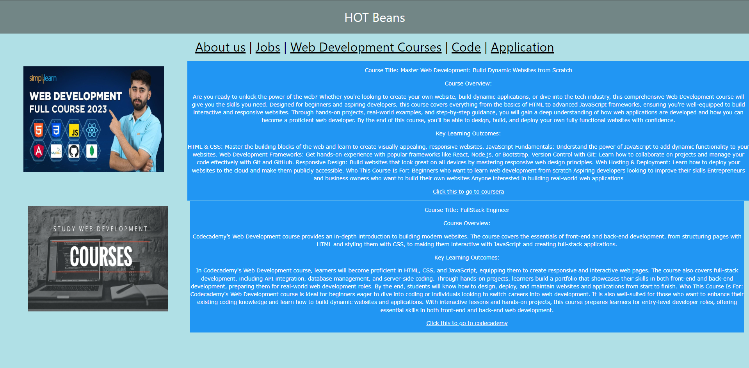

(After)

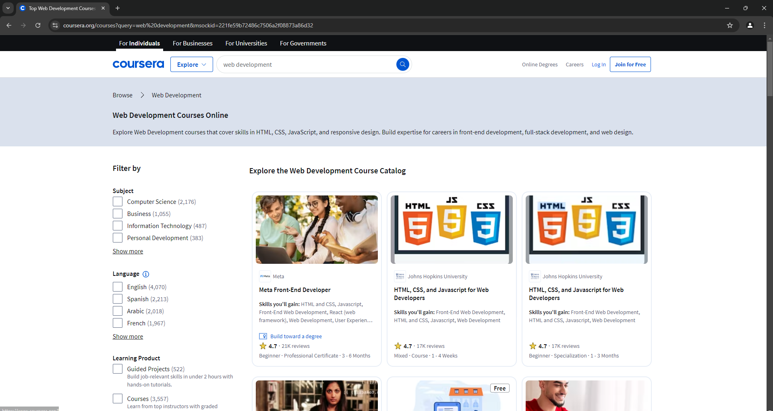The test was a success as it says on the website” Click this to go to Coursera” and it does take you to Coursera's page for web development courses.

Test 3:

For test 3 I am going to be testing my “Application page” and making sure that one they have entered their details and clicked submit they are taken back to the “About us” page as it states it does at the bottom.

(Before)

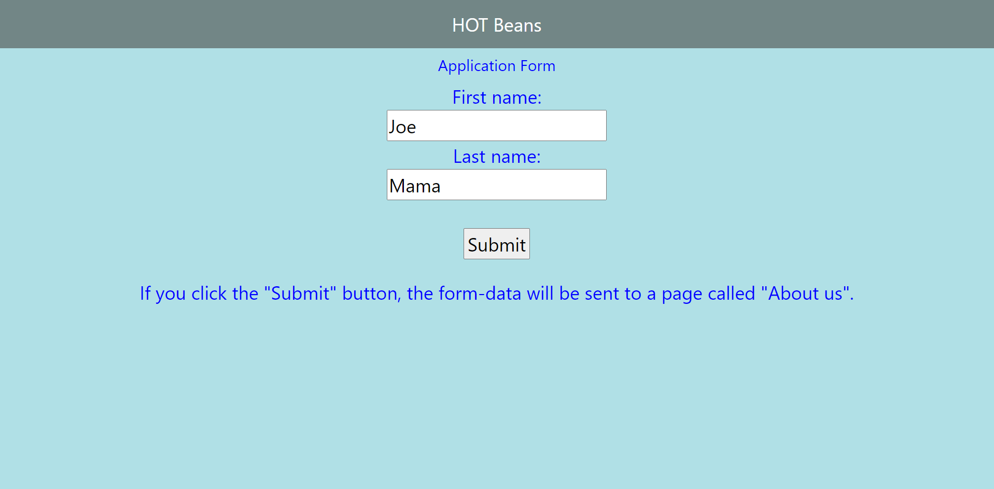(After clicking the submit button)

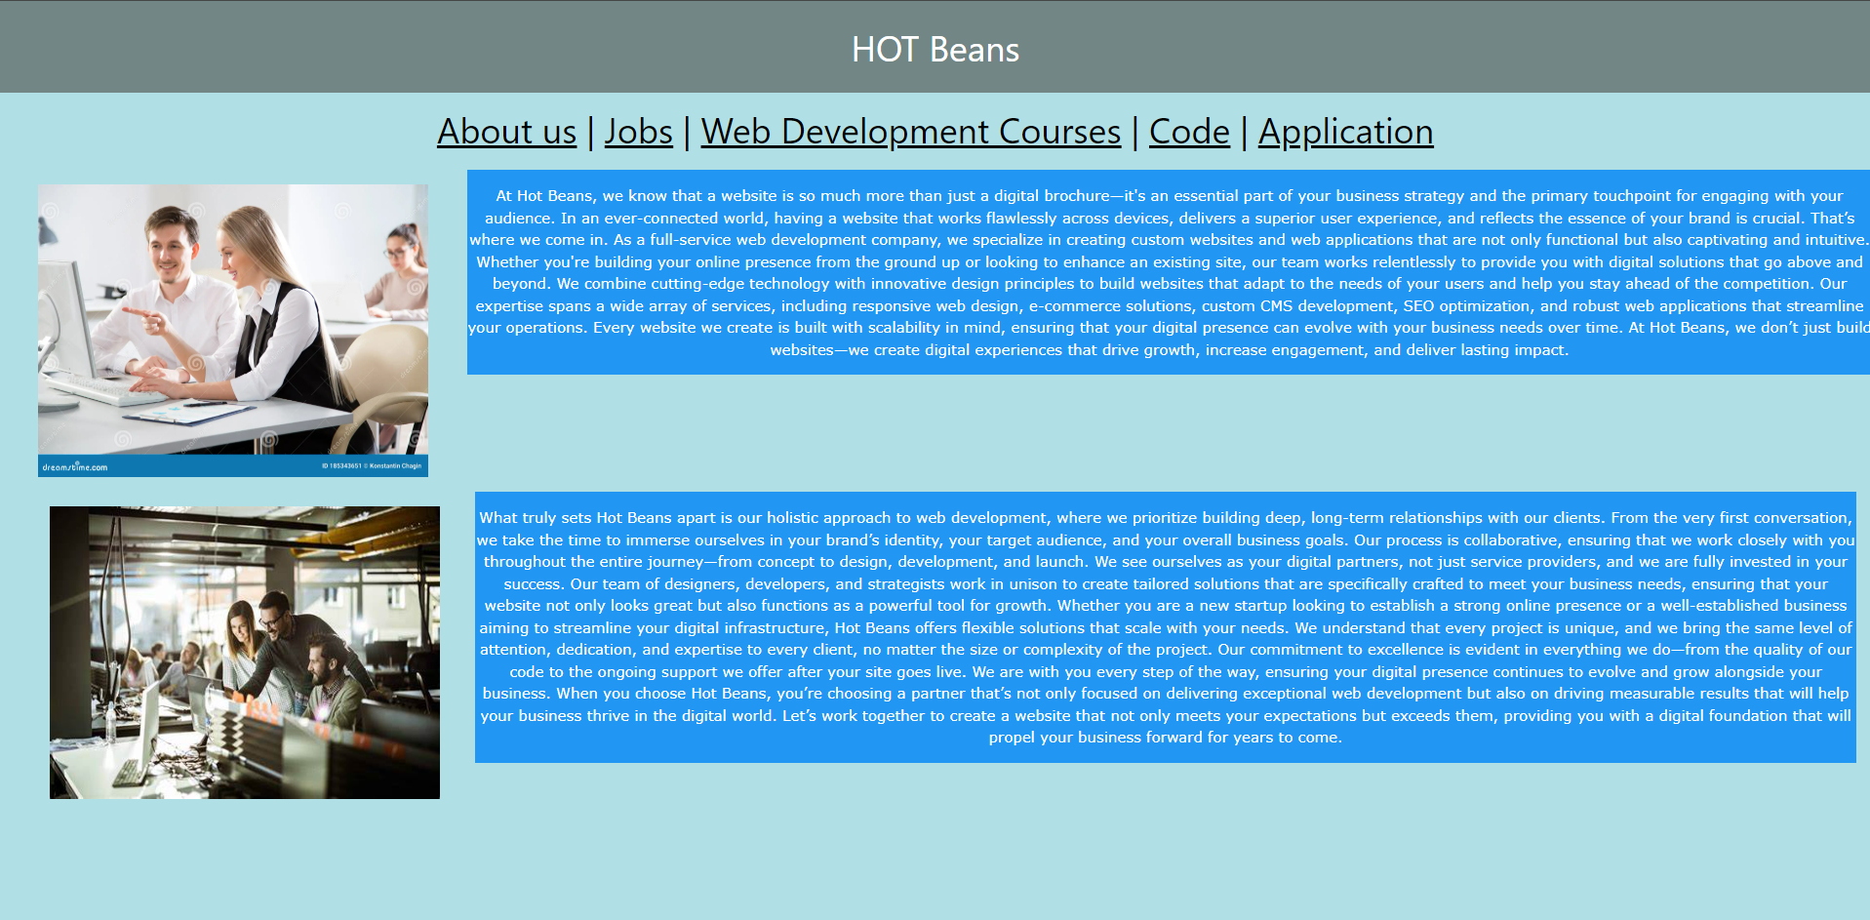

# Review how the website meets client requirements:

The company has asked me to include the following things:

* A profile of the company itself
* profiles of existing trainee web developers
* job specifications
* an on-line application form
* links to web development courses

I will go through each one of these bullet points and show how the website that I have created meets client requirements.

Bullet point 1:

I have created a profile of the company itself through the “About us” page where it describes everything about the company Hot Beans and what they are. (This is just a picture of the text on the about us page)

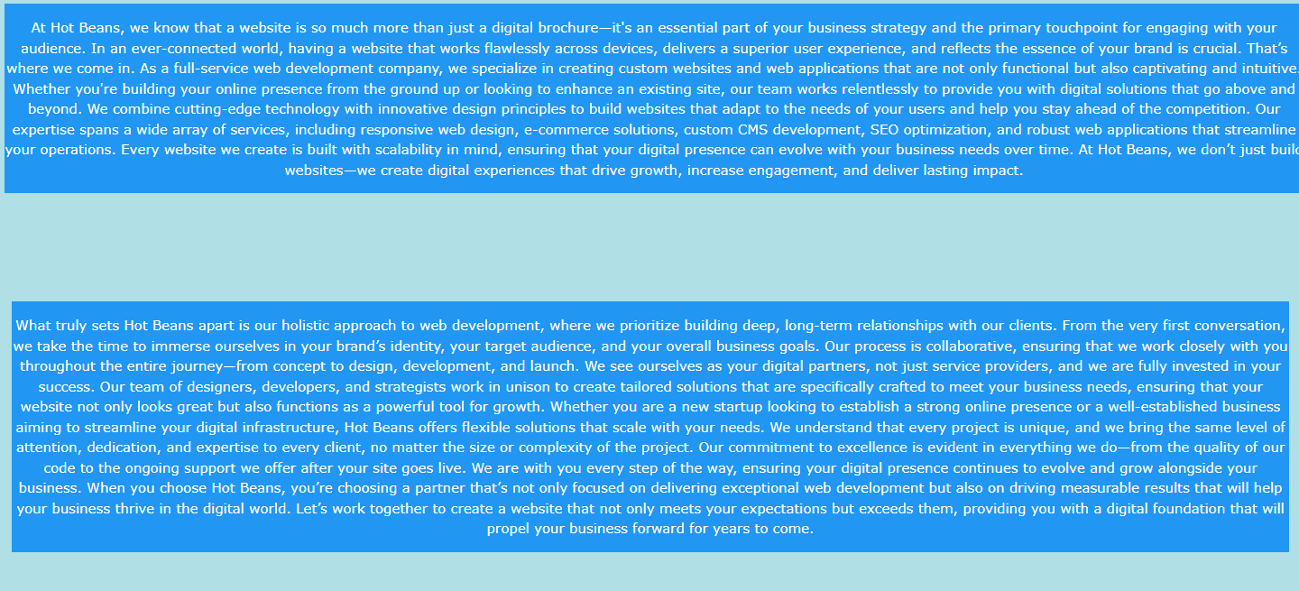

Bullet Point 2:

I have created profiles of previous existing trainee web developers through the “Jobs” page on the website which showed previous existing trainee web developers who worked at Hot Beans and shows a description of how they would work at Hot Beans and give an overview of what the job would be like.

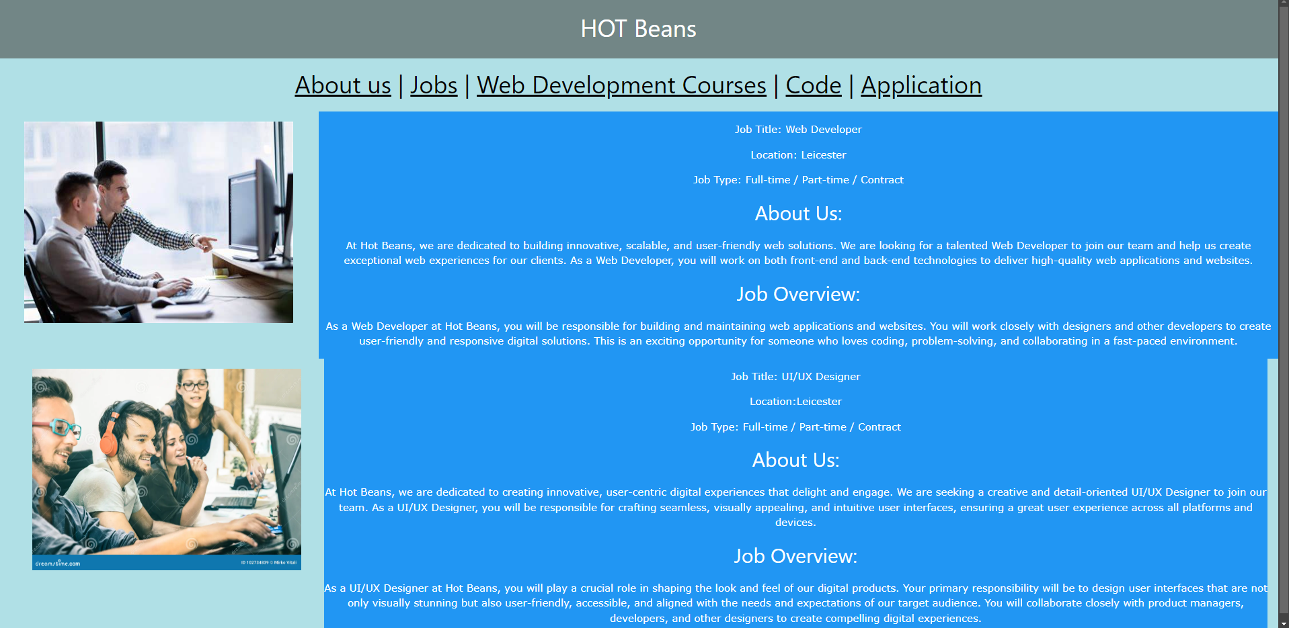

Bullet point 3:

This website shows job specifications again on the “Jobs” page where it shows the job title, location and job type with again a job overview.

Bullet point 4:

The website meets client requirements as it also contains an on-line application form on one of the pages where users can apply for the jobs through submitting their first and second name where the company will then contact them from there.

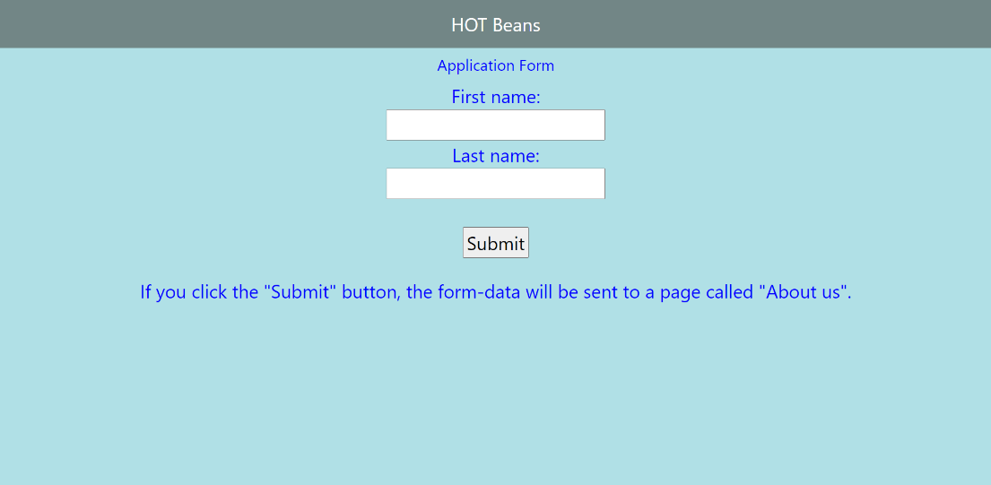

Bullet point 5:

The website also meets client requirements as one of them is to contain links to the web development courses which this website does as on the “Web Development Courses” page there is a link placed at near the bottom of each description.

# Evaluate the design and optimised website against client requirements:

Here I have a brown background that may cause eye strain on people that may have visual impairments therefore making my website less accessible so to change this colour would mean that the website would be more accessible and have easier usability.

I have made this no longer a problem through changing the background to a lighter colour allowing it to have less strain on users’ eyes and being more suitable which allows for the website to be more accessible. I have changed the colour through the body and background colour section where I changed it from brown to powder blue.

The header is visibly small and may be hard to see to users which will need to be changed and optimized so that it is bigger. This is due to a misspelling in the <h1-col> as it should just be <h1>A screenshot of a computer program
